CSCI590 - Final Report

1. progress

The major issues I solved are:

* #277 - [Bug in instagram feed - Feed does not expand upon clicking down arrow](https://github.com/pbehghader/CSSE_Research_Portal/issues/277)
* #360 - [Facebook events at React ver. Events page](https://github.com/pbehghader/CSSE_Research_Portal/issues/360)
* #362 - [Facebook upcoming events at React ver. Home page](https://github.com/pbehghader/CSSE_Research_Portal/issues/362)

Other trivial ones I solved/contributed are:

* #283 - [croneRoutes.js and dblp-server.js are almost identical](https://github.com/pbehghader/CSSE_Research_Portal/issues/283)
* #328 - [Update IG token](https://github.com/pbehghader/CSSE_Research_Portal/issues/328)
* #344 - [React branch cross-env port setting](https://github.com/pbehghader/CSSE_Research_Portal/issues/344)

To sum it up, I fixed the Instafeed on static html version and Facebook event display on Events & Home page on React vesion. I also retrieved the Instafeed and give a basic showcase solution on React branch. Apart from that, I enabled the React version to be developed across major platforms and did code cleaning regarding dblp data retrieval.

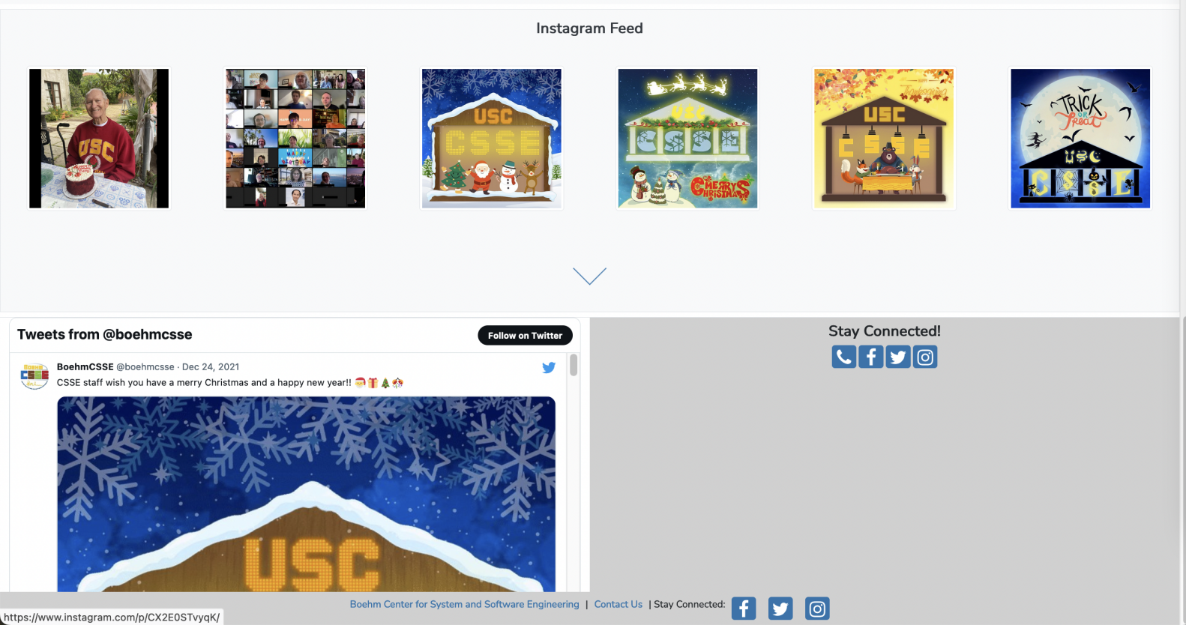

#277+#328

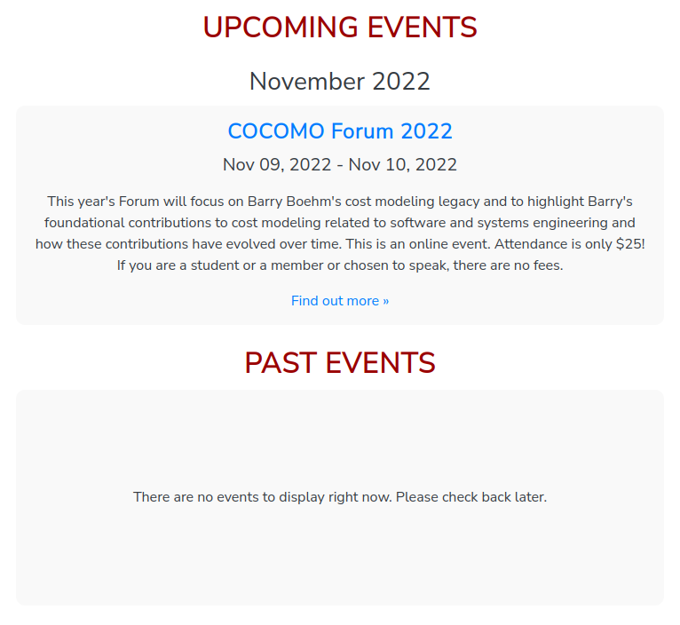

#360

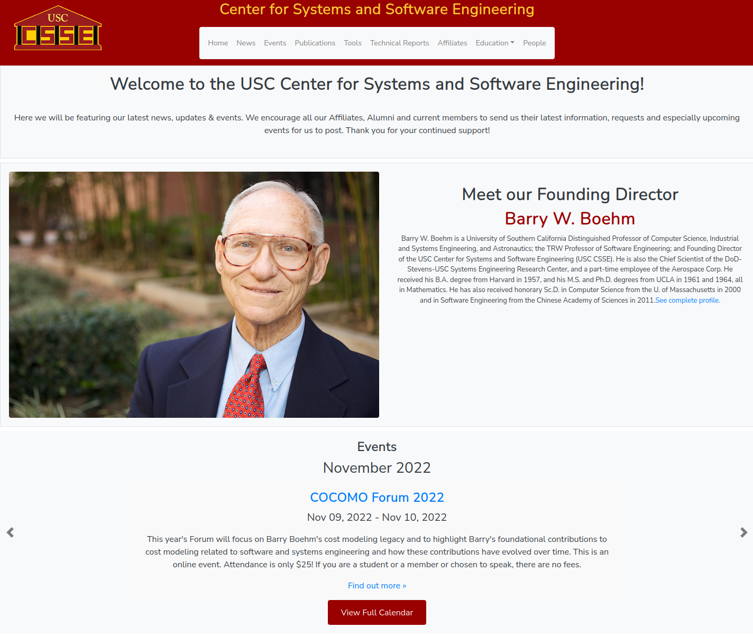

#362

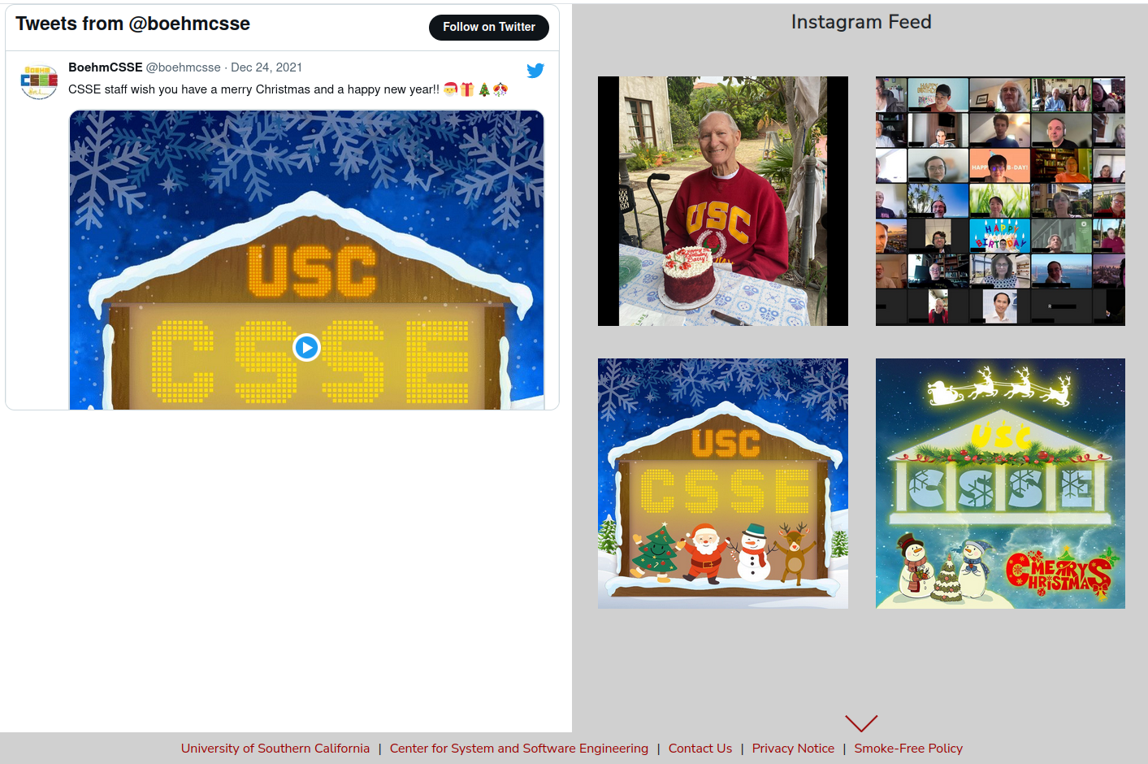

#277+#328 – React ver.

1. Summary

This is the first near-industrial project that I get to use JavaScript & React.js heavily since I learned them, thus being my first step to grow myself as a full-stack engineer. With 3 months of working, I got myself more familiar with techs like JavaScript, HTML, React.js (especially!), and Node.js. I also got the change to do a thorough research on introducing Facebook and Instagram feed into webpages which are common desired features nowadays.